Let's go shopping!
To help you understand the kind of lifestyle a typical 15th century Briton might have, we’d like you to go shopping in our medieval market.
The infogram below highlights some of the facts and figures about money, markets and lifestyle in the mid 15th century. (Late Medieval early Renaissance period).
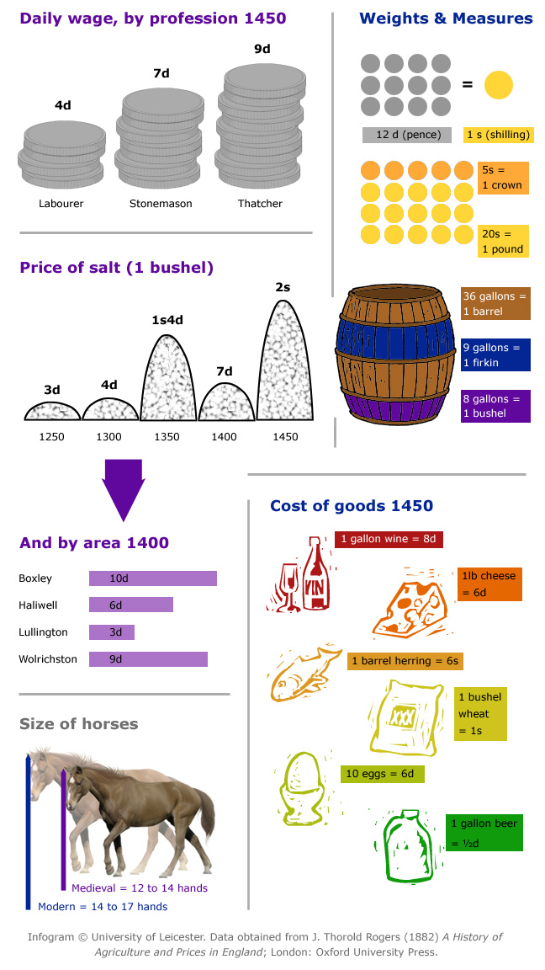

Before you start, choose one of the following roles:
- labourer (typical wage: 4d a day, or 2s a week)
- craftsman (typical wage: 8d a day, or 4s a week)
- landowner (an inherited income of 16s a week, but from this must pay 4 labourers to work their land)
Below is a table showing the price of various wares which you might need to survive. The prices are listed in shillings (s) and pence (d) - as you can see from the infogram there are 12d to a shilling. Refer to the infogram for quantities and conversions.
Create a weekly shopping list from your allocated budget, and describe it below, with your reasoning.
Goods | Quantity and price
Ale/beer | 1 gallon = 0.5d
Candles | 10 = 1d
Cheese | 1 large cheese = 6d
Cloves (spice) | 1 bag = 2s
Cow hides | 10 = 1s
Eggs | 10 = 6d
Fish | 1 barrel herring = 6s
Fuel (wood) | 40 bundles = 1s
Linen (for clothes) | 1 yard = 4d
Wool | 1 yard = 3s
Rabbits | 1 = 2d
Wheat grains | 1 bushel = 1s
Wine | 1 gallon = 8d
Pheasant | 1 = 1s

