Great Depression Vocabulary Foldable
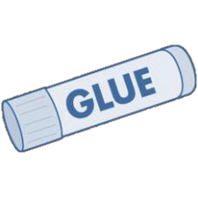

Directions: Cut out this foldable graphic organizer along the dotted lines and then fold and glue into your notebook. Underneath each term write a definition in your own words on one side and then draw a picture to represent the term on the other side of the flap.

Glue here into Your Notebook | 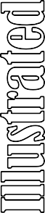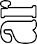 | Black Tuesday
Glue here into Your Notebook |  | Dust Bowl
Glue here into Your Notebook |  | Hawley-Smoot Tariff
Glue here into Your Notebook |  | Hoovervilles
Glue here into Your Notebook |  | New Deal
Glue here into Your Notebook |  | Bank Holiday
Glue here into Your Notebook |  | FDIC
Glue here into Your Notebook |  | CCC
Glue here into Your Notebook |  | AAA
Glue here into Your Notebook |  | WPA
Glue here into Your Notebook |  | Social Security

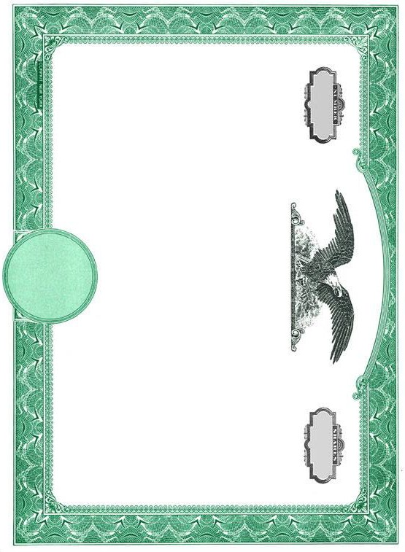

Laissez-Faire Government Policies

Directions: The Wall Street Crash of 1929, also known as Black Tuesday, was the most devastating stock market crash in America’s history and marked the beginning of the Great Depression. Cut out each of the stock certificates below and describe each cause of the crash on each. Then cut out the folder and glue it into your notebook so that
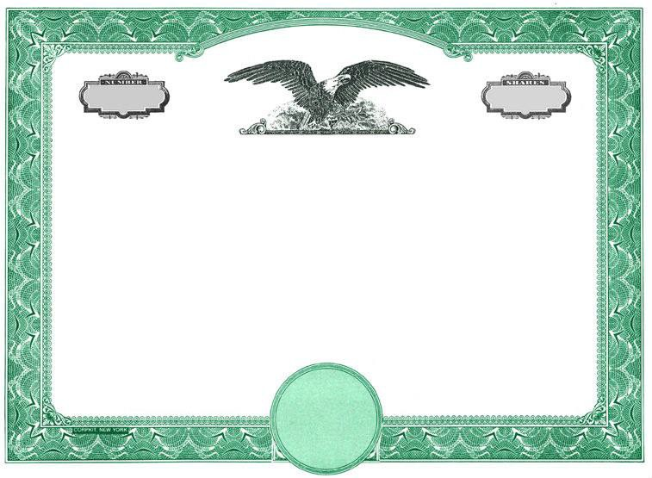
each certificate can be placed inside.

Buying on Margin

Overproduction of Goods


Causes of the Stock
Market Crash
Directions: The Dust Bowl was a period of severe drought and dust storms that damaged farms and towns across the Midwest and Central Plains. Cut out the graphic organizer and fold so that the map meets in the middle. Then color and label the areas affected by the Dust Bowl. Next, open up the flaps and answer each:

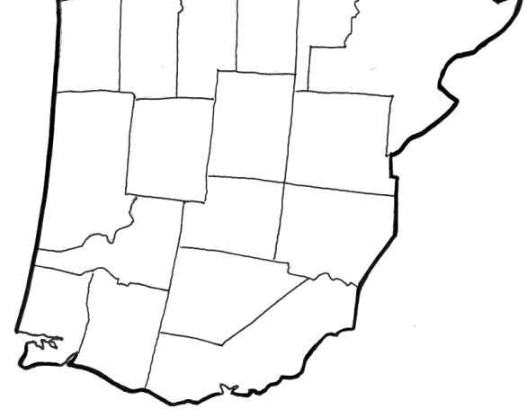
Who
Glue Goes Here and Paste in Notebook

Who as affected by the dust storms?

How
How were they affected? What did many do?






When
When did the storms take place?

Why
Why were the dust storms so bad? What caused them?

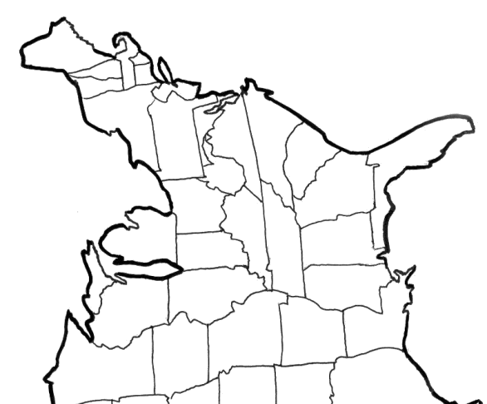



Directions: President Roosevelt's New Deal became known as the three "R's" of relief, recovery and reform. The programs created to meet these goals generated jobs and more importantly, hope for many Americans struggling to get by. Relief programs provided immediate action. Recovery programs were temporary ways to restart demand. Reform programs were permanent programs to avoid another depression. Cut out the organizer below and paste the top into your notebook. Under each flap, list the programs that apply to that “R”. On top of the paper, draw a New Deal-style poster to promote those programs.



Fold & glue tab

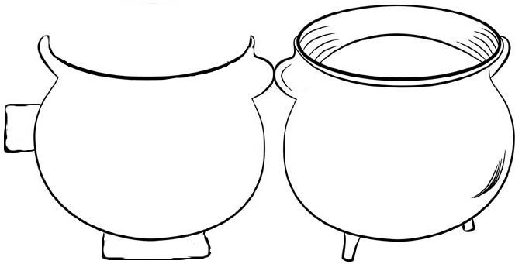
Directions: President Roosevelt’s New Deal created dozens and dozens of federal agencies designed to help ease the Depression. Cut out the soup bowl, fold, and glue in your notebook. Then cut out each letter card and on the back write out the agency’s full name and what it did.
Fold & glue tab
Glue the back of this
to your notebook.







,------------------1

I I
L -----------------

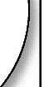


D

L -------------------


0
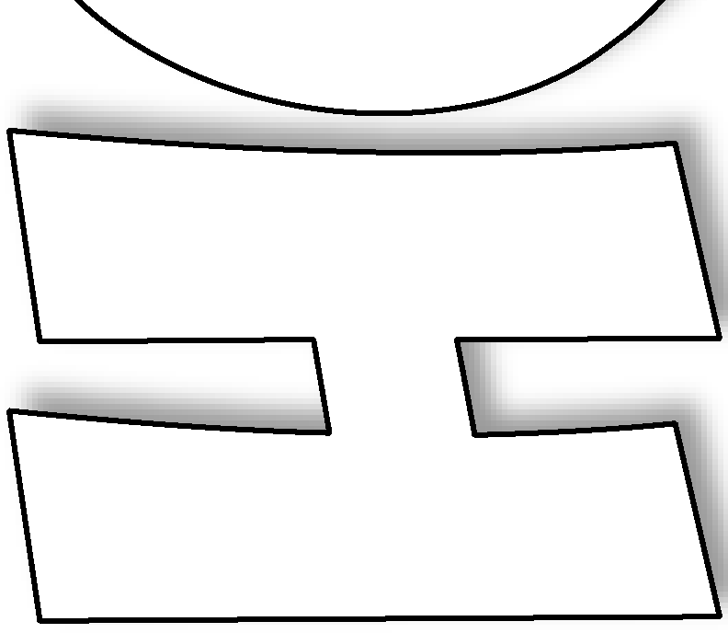

- - - - - - - - - - - --

Directions: Between 1933 and 1944, President Roosevelt gave a series of radio addresses known as “Fireside Chats”. Roosevelt's cheery voice and the direct communication helped connect him to the American people and increase his popularity. Cut out the graphic organizer below along the dotted lines and in each box explain what you think Roosevelt’s message to Americans was about each topic. What would he most want to get across?
Then, behind the fireplace, write how you think Americans felt about FDR based on these speeches.

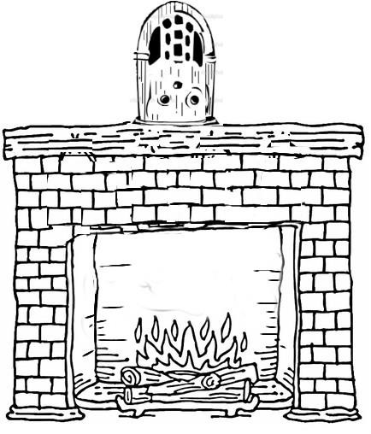
On the First New Deal (1933) On the 2nd New Deal (1935)

On the Start of WWII (1939)

On the Bombing of Pearl Harbor (1941)

On the Homefront (1942)

Directions: The worldwide economic depression of the 1930’s created turbulent times in many countries. Some experienced revolutions and others turned to militaristic dictators. Germany, Italy, Japan, and the Soviet Union are 3 countries who saw militaristic leaders rise to power during this time. Complete the chart below with information about what happened in each country in the decades between World War I and World War II. Include military actions, political changes, and alliances created/joined.

 |  |  | 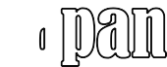
 |  |  |  | 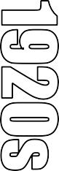
 |  |  |  | 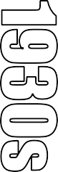
 |  |  |  | 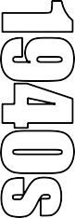

Directions: During Germany’s rise to power in the 1930’s, both England and France practiced appeasement rather than challenging Adolf Hitler’s actions. In the thought bubbles above each leader’s head write what they were thinking about appeasement. Then in the boxes at the bottom, write what appeasement made them seen as by the other leader.



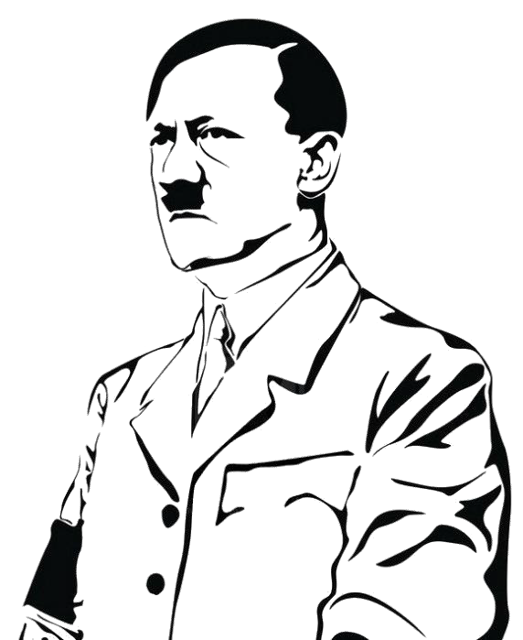
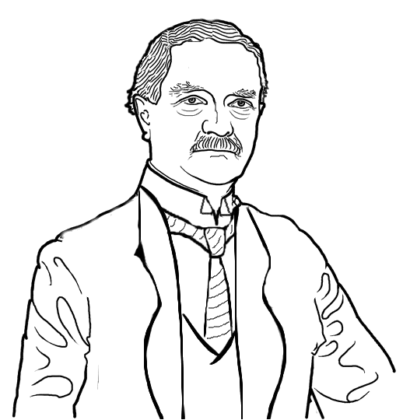










Neville Chamberlain

Seen as:
Adolf Hitler
Seen as:



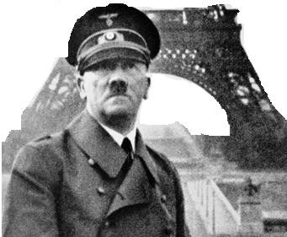
Nonaggression Pact

What 2 countries signed a pact in 1939?

Why did they make the agreement?

The Battle of Britain

Who defended Britain against the Nazi Luftwaffe?

What technologic advantage did they have?

Draw a “dog fight” below:

1939 1940 1941

Invasion of Poland

Why did the Nazi invasion of Poland start World War II?

Draw a “blitzkrieg” formation below:
Finish this picture of Hitler in front of the Eiffel Tower

Fall of France

Why did France fall so easily to the Nazis?


Directions: Cut out the timelines and glue them across 2 pages in your notebook so that it reads “Timeline of the Cold War” across the top of the 2 pages. The year 1939 should be on the far left and 1945 on the far right. Then complete the boxes by answering the questions, providing the information, or drawing pictures.

Pearl Harbor

Who attacked Pearl Harbor & why?

What was the result?

D -Day


Why was Normandy Beach selected for D-Day?

Draw some of the defenses Germany built:

1942 1943 1944 1945

Stalingrad

What was significant about this battle?
Iwo Jima Draw the famous photo taken at Iwo Jima:

Hiroshima and Nagasaki

Why did the US drop an atomic bomb on Hiroshima?

Draw a mushroom cloud below.

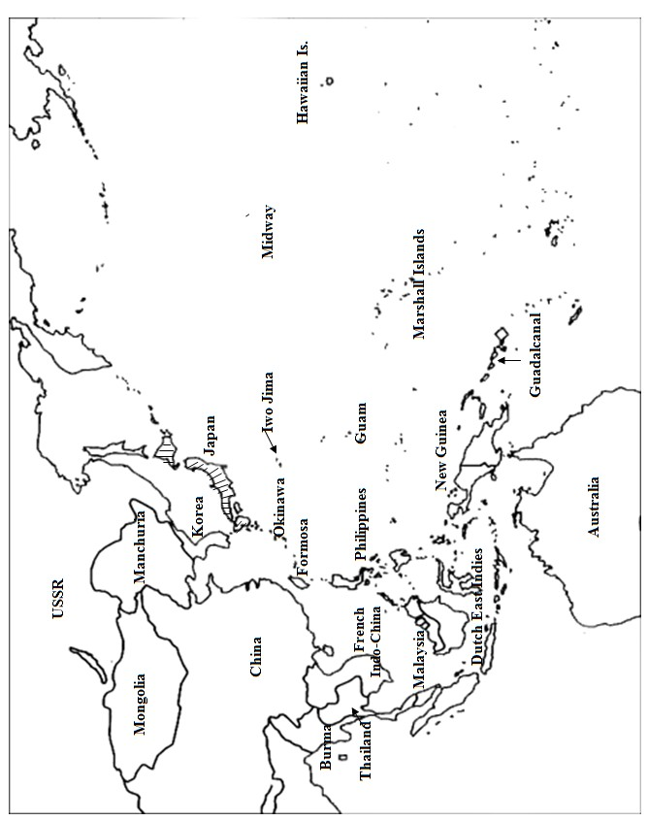
Directions: After entering World War II, America developed a plan for defeating Japan known as “Island Hopping” to gain military bases and secure the many small islands in the Pacific. Cut out and color this map then label the key islands the US “hopped” to and provide details in the boxes about the battles there.

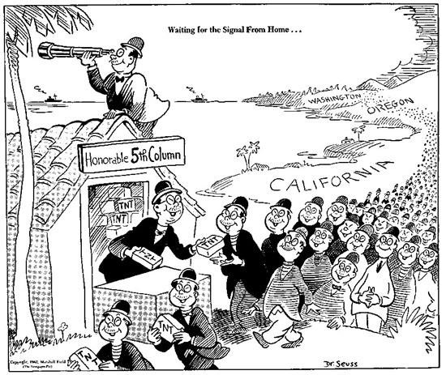
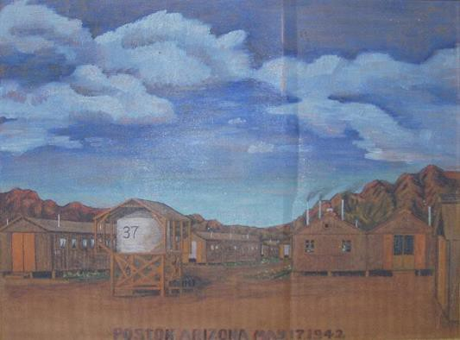
Directions: Starting in 1942, the US government forced about 110,000 Japanese-Americans who lived along the west coast into camps called “War Relocation Camps”. Most of the people held were there until the war ended in 1945. Cut out the graphic organizer below, then answer each question on notebook paper beneath the flaps.

1. How do you think Japanese-Americans reacted this?  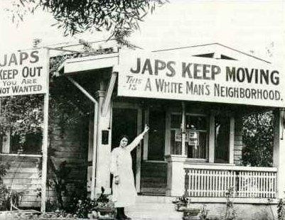 |  | 2. What was Executive Order 9066?  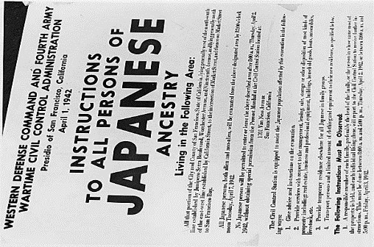
3. Describe how you think the children in this picture felt.  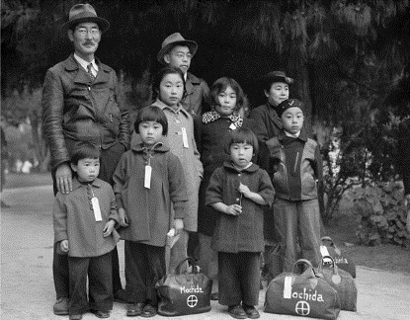 |  | 4. What adjectives could be used to describe the camp?  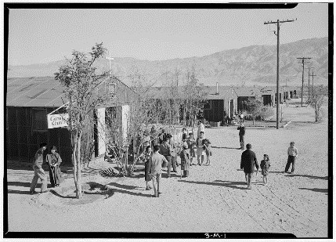
5. How does the artist portray the camp?  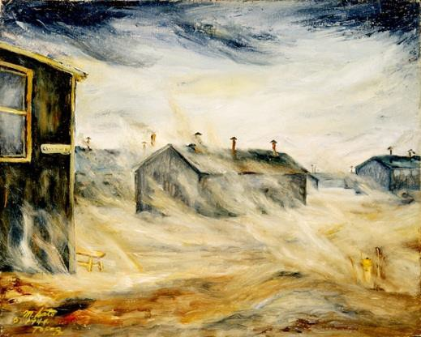 |  | 6. How do you think it felt to grow up in Manzanar?  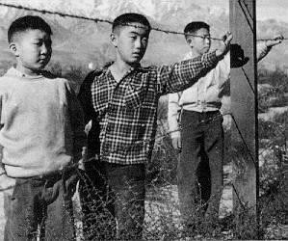
7. According to Dr. Seuss, why were Japanese put in camps? |  | 8. Do you think the US was justified in this policy?






Key things LEADING to
Geneva Convention

Key things RESULTING from Geneva Convention



Directions: While it actually comprises 4 separate treaties, the Geneva Convention usually refers to the agreements of 1949 about the humanitarian treatment of war. Those post World War II agreements were ratified by 196 countries. Cut out and complete the graphic organizers below to describe the impact of the Geneva Convention on the world and understand it in context of World War II
What was it?
Visual/picture that represents the Convention

Key things DURING the
Geneva Convention
Impact on the World Today

World War II Vocabulary Foldable
Directions: Cut out this foldable graphic organizer along the dotted lines and then fold and glue into your notebook. Underneath each term write a definition in your own words on one side and then draw a picture to represent the term on the other side of the flap.

Glue here into Your Notebook | 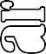 | Lend-Lease Act
Glue here into Your Notebook |  | Axis Powers
Glue here into Your Notebook |  | Allied Powers
Glue here into Your Notebook |  | Island Hopping
Glue here into Your Notebook |  | D-Day
Glue here into Your Notebook |  | Tuskegee Airmen
Glue here into Your Notebook |  | Rosie the Riveter
Glue here into Your Notebook |  | Navajo Codetalkers
Glue here into Your Notebook |  | Bataan Death March
Glue here into Your Notebook |  | Manhattan Project
Glue here into Your Notebook |  | Hiroshima

